Deployment of contract by 0xeF4FaAA5D1A2d23F7fCaec28570763C12BFF425c (Deployer):

Initially the deployer deployed the smart contract with the address 0xeF4FaAA5D1A2d23F7fCaec28570763C12BFF425c with total supply of tokens as 9000000 which is 90,000 DMU tokens which is based on ERC20 token smart contract on address 0x51A4F88bB2Cb6c3245eEfbbF29d171BFB16f3c5C

Smart contract deployed at address: 0xdA468bED3f13d6b145F5eFB08679F49A7998ac8a

Manufacturing Agent (0xeb32e2f77b61678a49E766FE6ae298934fbaAf42) registering on the DMU network.

Agent using the address of smart contract in the "at address" field register himself by putting number 1 in register text field. This simply means a manufacturing agent has registered the network.

Retailer (0x99adfb0699BD7b698b263F273d2A1B065f60DcB9) registering on the DMU network.

Retailer using the address of smart contract in the "at address" field register himself by putting number 2 in register text field. This simply means a retailer has registered the network.

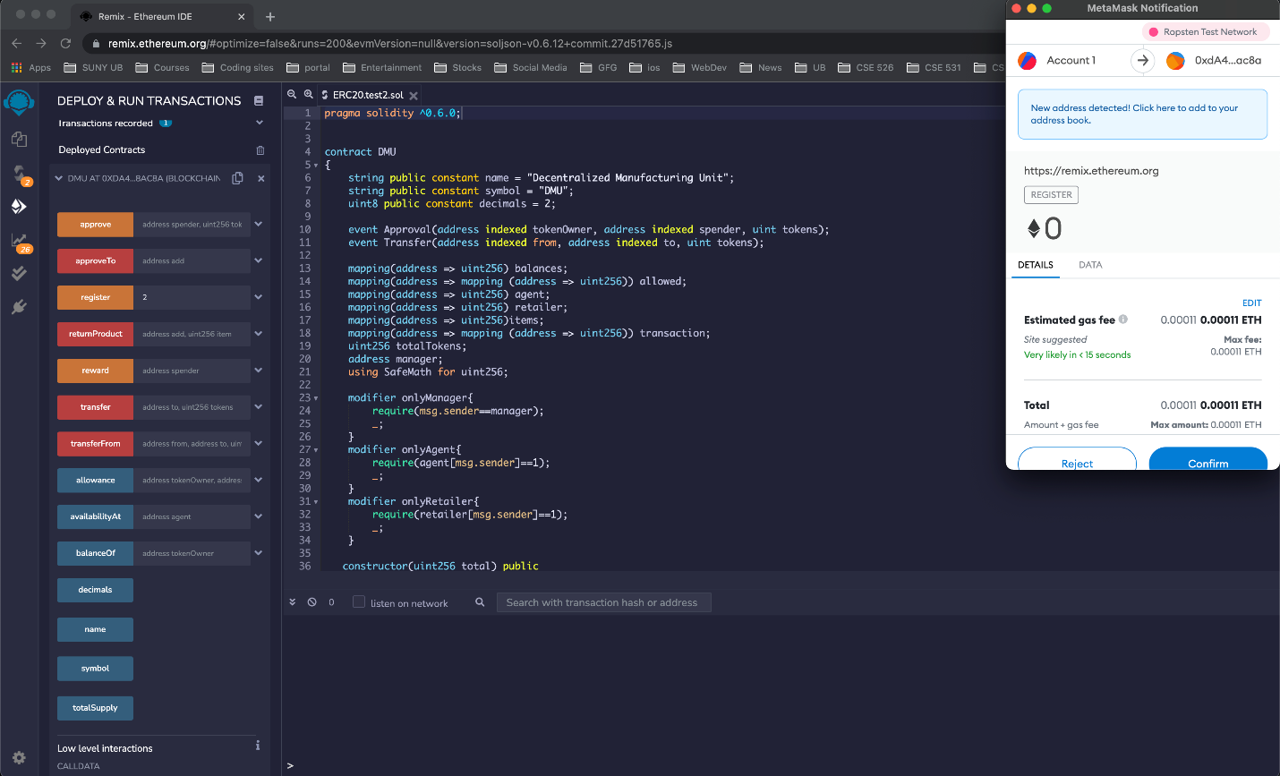

Deployer approves the registration request and awarding 1000 DMU to both the manufacturing agent and the retailer agent complete the transactions:

Retailer checks the availability of products with specific Manufacturing agent by using the special function i.e. by putting address of manufacturing agent in “availabilityAt” text field  
He then accordingly places the order.  
For placing the order retailer uses the transfer function. In the below case the retailer is purchasing 15 items from the agent.

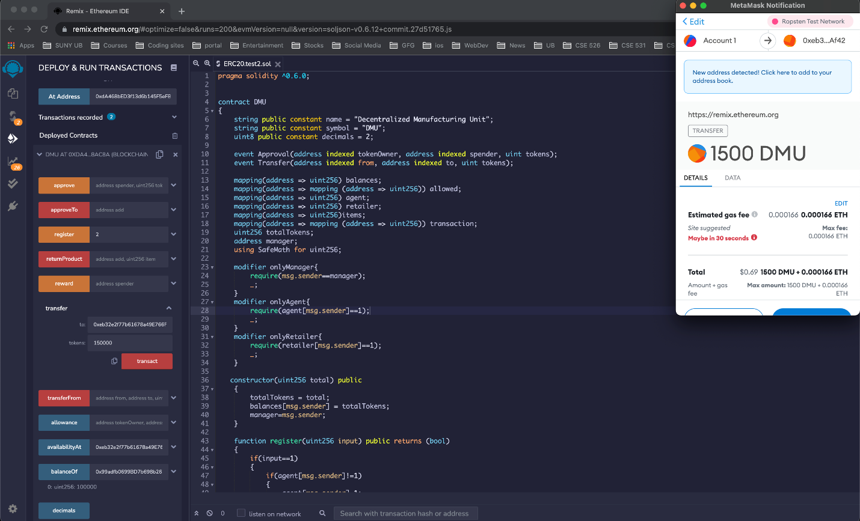

AvailabilityAt agent after transaction:

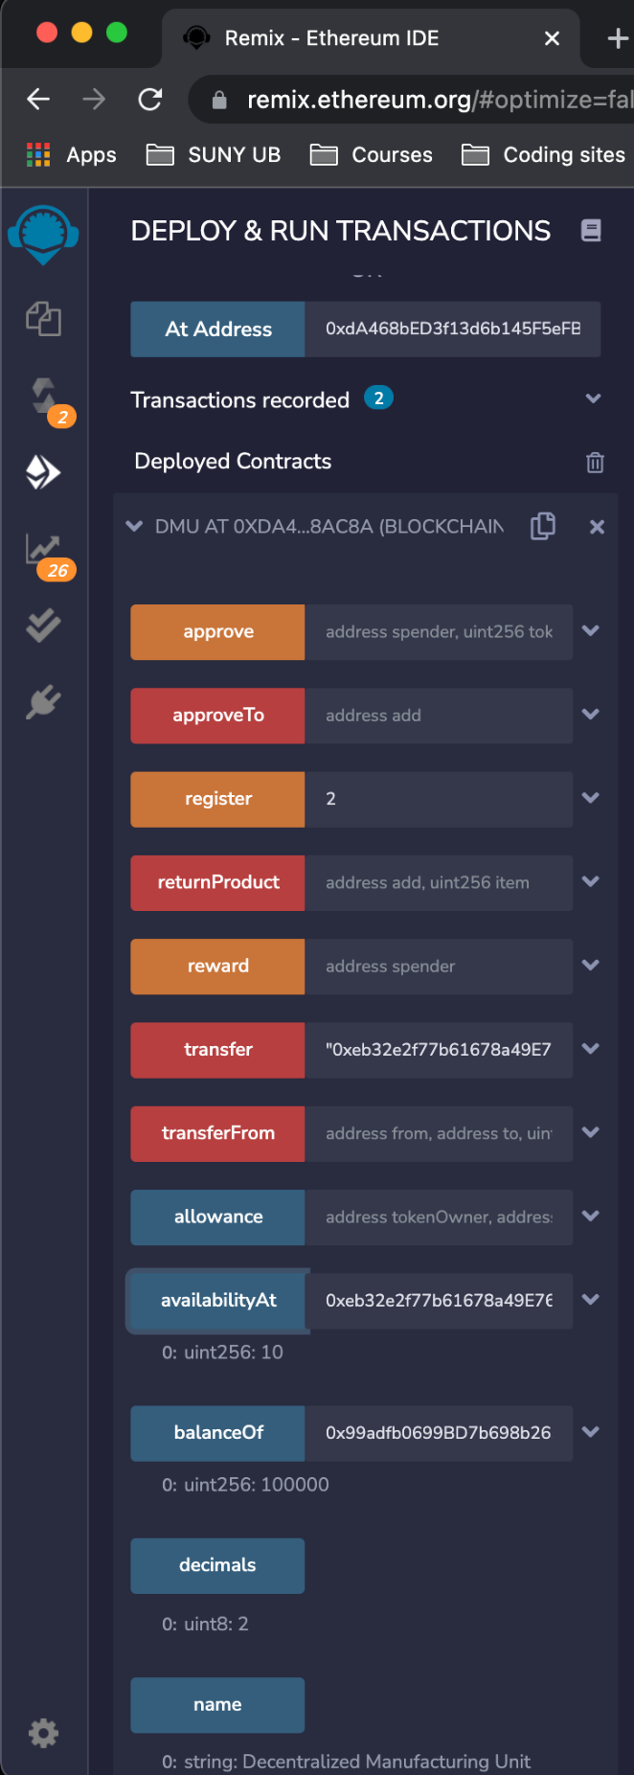

If retailer is not satisfied with the products he received then he can return the product. This functionality is performed by using special function "returnProduct". Retailer can mention the number of products he wants to return to which manufacturing agent.

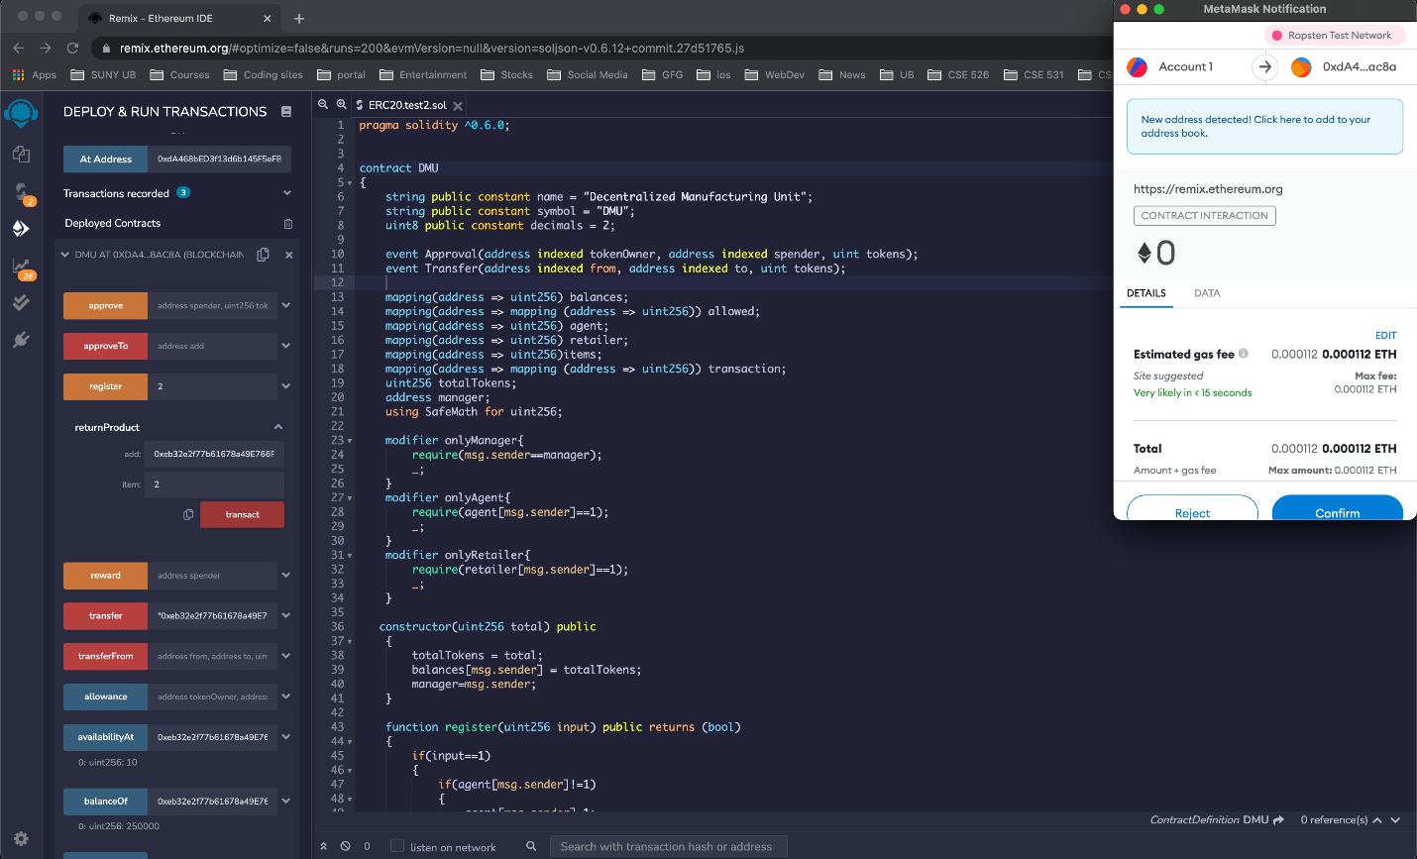

AvailabilityAt agent after returnProduct:

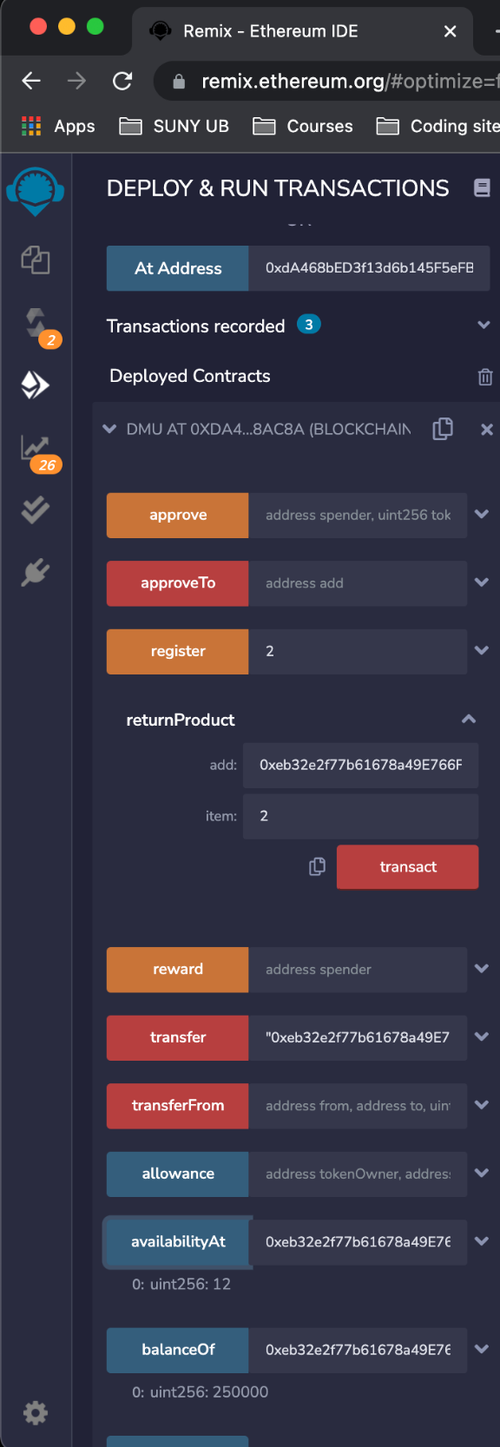

After 14 days (when the period of return policy expires) manufacturing agent gives reward to the retailer if he is eligible. Manufacturing agent rewards the retailer using the special function "Reward".

